





International Conference
ETHNOGRAPHY OF SILENCE(S)

1. 9. – 3. 9. 2026
University of Primorska, Faculty of Humanities
Titov trg 5, Koper/Capodistria, Slovenia

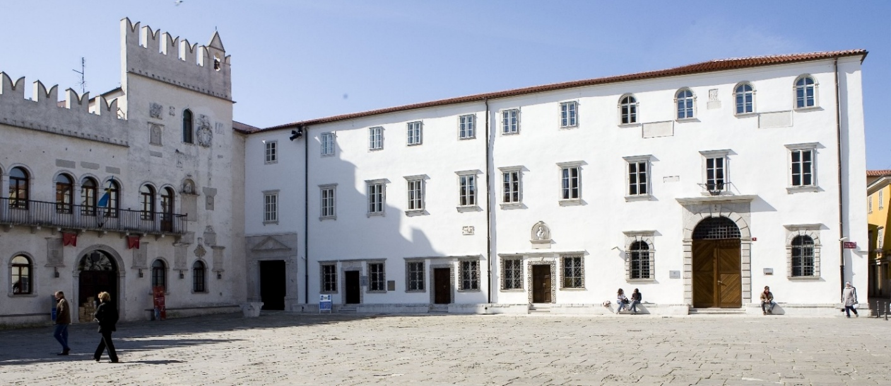

Ethnography of Silence(s): Conference Programme

Tuesday, September 1
13.00 – 14.00 Conference Registration (Faculty of Humanities, lobby)
14.00 – 14.15 Conference Opening (Burja 1 lecture theatre): Klavdija Kutnar (university rector) and Aleksander Panjek (dean)

PANEL 1: Memories and Silences in Borderland Region (chair: Katharina Eisch-Angus, University of Graz)
14.15 – 14.45 Katja Hrobat Virloget (University of Primorska) | An Ethnography of Silence and Reconciliation: Trauma, Memory Conflicts, and Ethnic Identities in the Istrian-Dalmatian Exodus
14.45 – 15.15 Petra Kavrečič Božeglav (University of Primorska) | Slovenes and Italians Living in the Karst Area of Italy: Stories, Conflicts, Ignorance and Perceptions
15.15 – 15.45 Urška Lampe (Institute IRRIS Centre for Oral History) | Prescriptive Forgetting or Humiliated Silence? The Case of Post-Second World War Mass Killings in Slovenia
15.45 – 16.15 Anja Moric (Institute for Ethnic Studies, Ljubljana) | Interrupted Continuities: Silence, Heritage, and Reconciliation in Gottschee
16.15 – 16.45 Daniel Wutti (University of Teacher Education Carinthia) | Challenging National Narratives with Memory Cultures of Minorities
16.45 – 17.00 Short break

17.00 – 19.00 “The Shadows of Silence”: film screening and discussion (University Library), film directors: Jure Kreft, Darko Sintič
Project RE 4 Healing: Crossborder Remembrance, Reconnection, Restoring and Resilience (European Commission, CERV)
Speakers: Katja Hrobat Virloget (University of Primorska, project leader), Jure Kreft & Darko Sintič (Fixmedia), Manca Švara (Epiona, project partner) and Špela Španžel (Ministry of Culture, Directorate for Cultural Heritage, associated partner); chaired by Daniel Wutti (University of Teacher Education Carinthia, project partner)

19.00 – late: WELCOME DINNER in Foresteria – Atrium (Faculty of Humanities)

Wednesday, September 2
9.00 – 9.45 KEYNOTE (I): Kathrin Pabst, Stiftelsen Statsraad Niels Aalls Minde, Norway | Working with the Untold: Silence, Family Secrets and the Long-Term Consequences of War

PANEL 2: Memory, Conflict and Trauma (chair: Steve Matthewman, The University of Auckland)
10.00 – 10.30 Petra Hamer (University of Ljubljana) | When Silence Speaks: Ethnographic Encounters with Absence and Trauma in Prijedor, Bosnia-Herzegovina
10.30 – 11.00 Emina Zoletić (University of Warsaw) | Beyond Silence: Generational Negotiations of War Memory in Post-Conflict Bosnia
11.00 – 11.30 Mihaela Trișcă Zăgreanu (University George Emil Palade of Târgu Mureș) | Unaddressed Histories and Institutional Silence as Catalysts of Interethnic Conflict
11.30 – 12.00 Bleona Kurteshi (University of Regensburg) | Heroic Recognition and the Persistence of Silence regarding Wartime Sexual Violence in Kosova
12.00 – 12.30 Nikola Puharić (Serbian National Council in Croatia) & Branka Vierda (Independent Researcher) | Producing Absence: Silence, Violence, and Post-War Governance after Operation Pocket-93

12.30 – 14.00 LUNCH (Gostilna Labirint, Čevljarska ulica 9)

PANEL 3: Silence and Structural Violence (chair: Marko Galič, University of Primorska)
14.00 – 14.30 Ana Bezić (Stanford University) | Silence as Uncomfortable Labour and Landscapes of Care in Srb, Croatia
14.30 – 15.00 Eino Heikkila (University of Jyväskylä) | Listening to What Is Not Said: Silence, Aging, and Communal Living
15.00 – 15.30 Nina Vodopivec (The Institute of Contemporary History, Ljubljana) | The Silencing of Industrial Labour: Acts of Structural Violence
15.30 – 16.00 Sanja Potkonjak (University of Zagreb) | Progress That Doesn’t Listen: Energy, Dispossession, and Developmental Futures on the Lika River
16.00 – 16.30 Nastja Slavec (ZRC SAZU, Ljubljana) | Ambiguous Traces: On the Silences and Muted Narratives of the Basque Political Conflict

16.30 – 17.00 Afternoon break
17.00 – 17.45 KEYNOTE (II) : Michèle Baussant, CNRS, Institute des Sciences Sociales du Politique, Paris, France | From Forced Displacement to the memory of displacement: remembrance, forgetting, and silence
17.45 – 18.00 (Armerija hall): Exhibition In the garden of the (in)visibles by Roberta Altin, Giuseppe Grimaldi (University of Trieste), Katja Hrobat Virloget (University of Primorska) and Alessandro Monsutti (Geneva Graduate Institute)

Thursday, September 3
9.00 – 9.45 KEYNOTE (III): Tracey McIntosh, School of Māori and Pacific Studies, The University of Auckland, Aotearoa / New Zealand

PANEL 4: Approaching Silence in Indigenous World and Beyond (chair: Manca Švara, Epiona Institute, Koper)
10.00 – 10.30 Maja Ćurčić (Sociantro Institute) | Hyper-Incarceration of Māori: Narratives of Imprisonment and the Violence Continuum
10.30 – 11.00 Martina Tonet (University of Primorska) | The Struggle for Cultural Survival on the Navajo-Hopi Disputed Land: De-coding Silence in a Diné Remote Community
11.00 – 11.30 Steve Matthewman (The University of Auckland) | The Residential Red Zone as a Haunted Landscape: Explorations in the Ethnography of Silence
11.30 – 12.00 Eszter Gyorgy (Eötvös Loránd University, Budapest) | Archival Silences: The Memory of the Roma Settlement Clearances in Pesterzsébet
12.00 – 12.30 Marko Galič (University of Primorska) | Intergenerational Trauma and Healing or What Can We Learn from Indigenous Epistemologies

12.30 – 14.00 LUNCH (Gostilna Labirint)

PANEL 5: From Silence to Resistance (chair: Martina Tonet, University of Primorska)
14.00 – 14.30 Richard Papp (Eötvös Loránd University, Budapest) | Absence and Silence in Hungarian Holocaust Memory
14.30 – 15.00 Asya Gefter (Artist and Researcher, Trieste) | Stories of Not Asking and Not Telling: The Architecture of the Vacuum
15.00 – 15.30 Ana Dević (University of Bologna & KU Leuven) | Aesthetics of Silence and Absence in Memory Activism: Against the Silencing of War Atrocities in Serbia
15.30 – 16.00 Christina Sterniša (University of Graz) | Listening to the Ambiguity of Silence: Women’s Resistance and Postwar Memory in Greece

16.00 – 16.30 Afternoon break
16.30 – 16.45 (Reading Room, level 5): Exhibition Sixty years of the Black Panther Party by Marko Galič, Andrea Gorenc Lonzarič, Dora Plantarič and anthropology students from the University of Primorska

THE CLOSING ROUNDTABLE: Towards Reconciliation
16.45 – 17.45 The Closing Discussion and Reflection with Tracey McIntosh, Michèle Baussant and Kahtrin Pabst, chaired by Katja Hrobat Virloget and Daniel Wutti
17.45 The Closing Song (Marko Galič, Martina Tonet)

18.00 – late CONFERENCE DINNER (Capra Restaurant, Grand Hotel Koper)

Please note:
All keynotes and panels will be held in Burja 1 lecture theatre (Faculty of Humanities Koper). Conference meals (welcome dinner, lunch 2x, and conference dinner) are covered for all registered conference delegates and are free of charge.
The conference is funded by two research projects: Ethnography of Silence(s) (ARIS J6-50198) and RE4Healing: Crossborder Remembrance, Reconnection, Restoring, and Resilience (European Commission, CERV Citizens, Equality, Rights and Values Programme).

For more information, please contact conference coordinators Katja Hrobat Virloget (katja.hrobat@fhs.upr.si), Martina Tonet (martina.tonet@fhs.upr.si) or Marko Galič (marko.galic@fhs.upr.si).
Dobrodošli and Welcome to Koper/Capodistria!

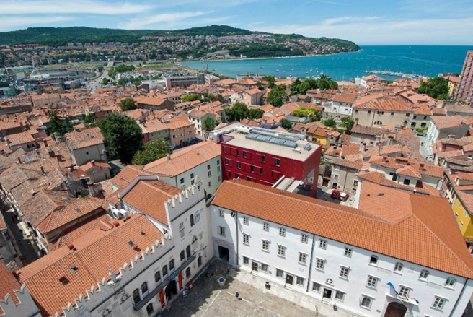

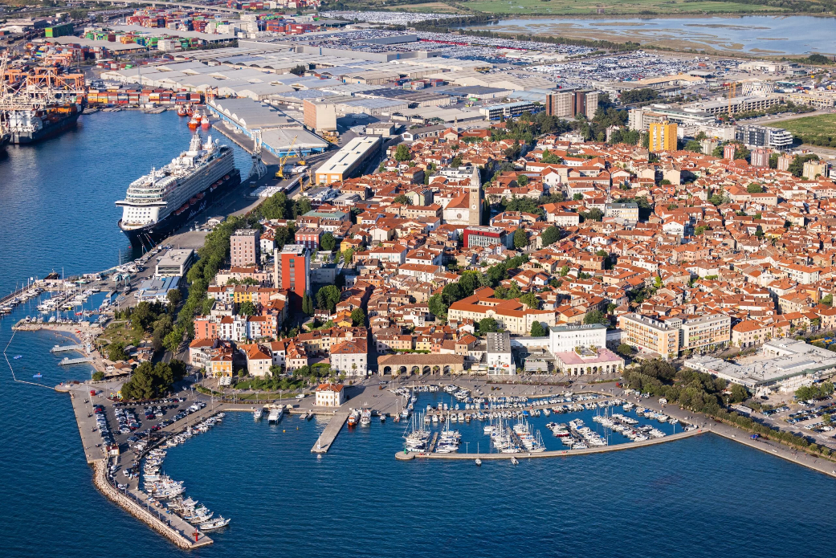

Upper photo: University of Primorska (Faculty of Humanities = red building)
Lower photo: Koper from air (visitkoper.si)

Funded by the European Union. Views and opinions expressed are however those of the author(s) only and do not necessarily reflect those of the European Union.Neither the European Union nor the granting authority can be held responsible for them. https://fhs.upr.si/re-4-healing-crossborder-remembrance-reconnection-restoring-and-resilience/

